XOR Function Using Linear inequalities and Graphical

Representation :-

|  |  |  |  |
| --- | --- | --- | --- |
| X0 | X1 | XOR | Equations |
| 0 | 0 | 0 | w0 + 𝚺i=12 wixi < 0 |
| 0 | 1 | 1 | w0 + 𝚺i=12 wixi >= 0 |
| 1 | 0 | 1 | w0 + 𝚺i=12 wixi >= 0 |
| 1 | 1 | 0 | w0 + 𝚺i=12 wixi < 0 |

By Simplifying the equations :-

w0 + w1.0 + w2.0 < 0 => w0 < 0

w0 + w1.0 + w2.1 >= 0 => w2 > -w0

w0 + w1.1 + w2.0 >= 0 => w1 > -w0

w0 + w1.1 + w2.1 < 0 => w1 + w2 < -w0

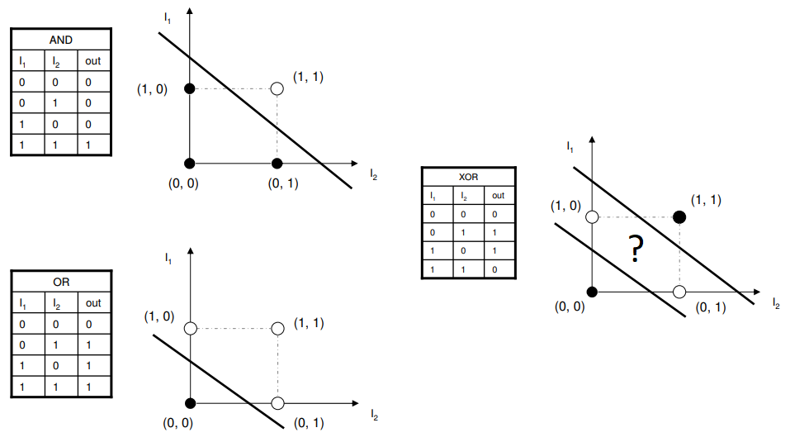

Fig : XOR Graph